Year 5/6 Creative Homework
Summer 2 2025

This half term we will be learning about exploration in English, the changing role of women in history, Artificial Intelligence in DT. To immerse yourself further within these topics we are setting optional homework tasks. Select an activity or activities from the choosing grid – you can complete as many as you like and be creative!
During the week beginning 21st July we will be having a homework showcase where you will get the chance to share your amazing work so please bring everything in that week. Alternatively, you can email pictures or documents to office@willoughby.notts.sch.uk and we can share them with the class. We look forward to seeing all your efforts!

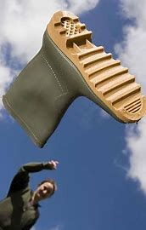  It’s nearly sports day, so put in some practice! Try these:  - How far can you ‘wang a welly’?  - Can you run on the spot for 60 seconds? How about for 2 minutes?  - Do a standing long jump – how far can you jump? Can you beat your mum/dad/sister/brother/cousin? | 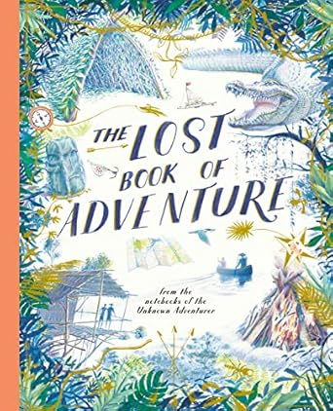  We have been enjoying the book ‘The lost book of Adventure’ and reading some amazing survival stories. Write your own story inspired by things we have read at school. You could make a comic strip if you like. Think about the threats and dangers… will you survive?
  In D&T we will be learning about Artificial Intelligence, in particular Smart Devices, like an Alexa. Talk to your adults at home and find out how many Smart Devices you have in your home. What tasks can they do and are they helpful or not? Record what you find out in a table. Are there any other tasks for which you think a Smart Device could be useful? | 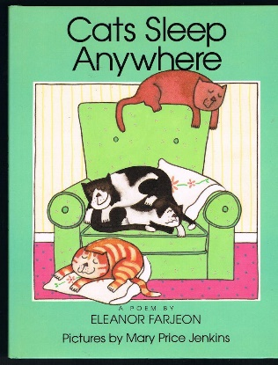  We have learnt the poem ‘Cats sleep anywhere’ off by heart. Choose a poem of your choice, practice saying it out loud thinking about rhythm and tempo. Can you learn it off by heart and perform it in front of the class (or just to Mrs Hollis)?
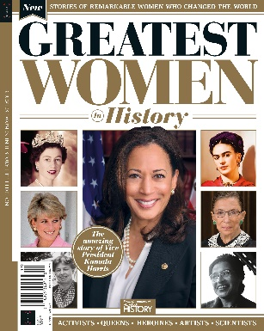  We are learning about the changing roles of women in history. Choose a famous and influential woman to write a fact file about. This could be a booklet or on the computer. You could even record a podcast! | 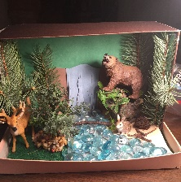  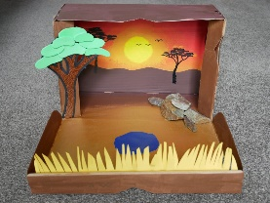  We are finishing our topic on biomes in geography. Can you create your own diorama (3-d model) of a biome – a show box works well. When you bring it into class, we will guess which biome you have created.

