Year 5/6 Creative Homework
Autumn 1 2025
This half term we will be learning about forces in science, maps and the rainforest in geography, surrealism in art and respectful relationships in PSHE. To immerse yourself further within these topics we are setting these exciting homework tasks. Select an activity or activities from the choosing grid – you can complete as many as you like and be creative!
We will be having a homework showcase during the week beginning 13th October where we can celebrate your amazing work so please bring everything in that week. Alternatively, you can email pictures or documents to office@willoughby.notts.sch.uk and we can share them with the class. We look forward to seeing all your efforts!
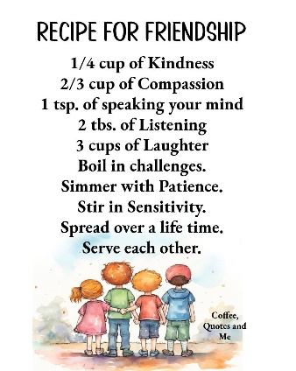  Write a recipe for friendship using recipe-writing language, e.g. 200g of kindness, 100g of thoughtfulness, two tablespoons of humour - you get the idea!  You could type this up and email it to school. | 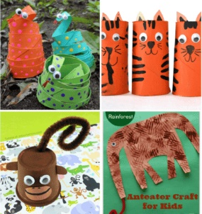  Get crafty and creative! Can you make a rainforest animal using paper, material, buttons, toilet rolls, tin foil, leaves, paper clips… what do you have at home?  Think about your animal and why they are suited to that habitat. Where abouts in the rainforest do they live? Write a fact file to accompany the animal you’ve made.
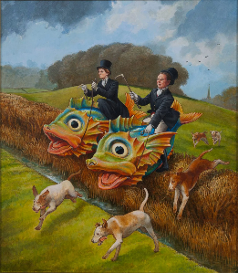  Imagine you open a drawer and inside is something completely unexpected… not socks or pencils, but maybe a flying teapot, a staircase made of jelly, or a giraffe reading a newspaper!  Your challenge is to draw what’s inside your surreal drawer and explain why it’s there | 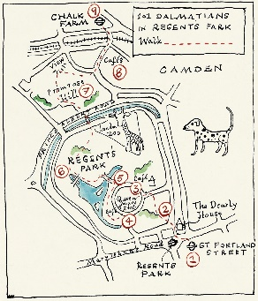  Create your own map. It could be a map of a town, a treasure map, a new country or island or a map of your house. Make sure to add features of a map:  - A title  - A compass rose  - A key  - A scale.
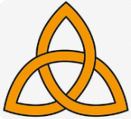  Write a short script or record a video where you “interview” the three persons of the Trinity. Ask questions like:  - “What is your role?”  - “How do you help Christians today?”  - “Why are you important?” You can act it out with friends or family, or write it as a comic strip! | 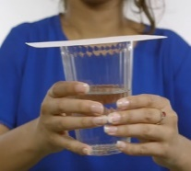  Try this water trick…  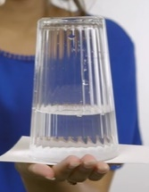  Fill a glass half full with water. Pop a piece of card on top of the glass. Turn the glass of water upside down (holding on to the card). They carefully remove your hand from the card and just hold the glass.  What surprised you about what you saw? Which forces are at play here? Why does the water not fall to the ground?  Apart from water, what else is in the glass?

