Year 3/4 Creative Homework
Spring 1 2026
This half term we will be learning about electricity in science, international trade in geography, the work of Kandinsky in art lessons, keeping ourselves safe in PSHE and fruits in French. To immerse yourself further within these topics we are setting these exciting homework tasks. Select an activity or activities from the choosing grid – we would like you to complete at least one please!
We will be having a homework showcase during the week beginning Monday 9th February where we can celebrate your amazing work so please bring everything in that week. Alternatively, you can email pictures or documents to office@willoughby.notts.sch.uk and we can share them with the class. We look forward to seeing all your efforts!
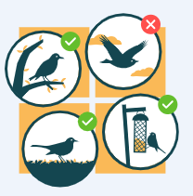  Be curious about the birds in your garden and take part in the RSPB Big Garden Bird watch on the weekend of 23rd - 25th January.  Sit quietly, count and record any birds you see. All information and record sheets can be found on the RSPB website -  https://www.rspb.org.uk/whats-happening/big-garden-birdwatch .  Bring your recording sheet in to school. | 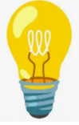  Science: People often say that Thomas Edison invented the light bulb, but is that really true? Your job is to investigate! See where your curiosity leads you and create a poster to answer the question:  Who invented the electric light bulb?
  Imagine you are a single raindrop and draw a map showing your journey from the cloud to the river to the sea. How many different watery situations do you experience on the way. Perhaps someone drinks you, or you tumble over the Victoria Falls in Africa. Describe each place and how you feel there. | 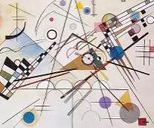  Art Kandinsky’s art was often inspired by music. Turn on your favourite piece of music and whilst you listen create a piece of abstract art that includes:  - different shapes  - different types of lines  - A mix of warm and cool colours  - A feeling or mood you want to express (e.g., calm, excitement, mystery).  Write notes to explain how the music inspired you.
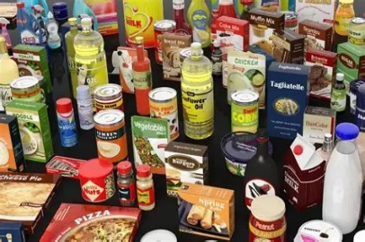  Look at the food packaging on 10 items and find out the ‘food miles’ for each item. You could draw or label this on a world map.  How many items can you find that are produced in England? | 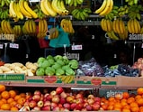  Can you design a stall in a French market stall selling fruits. Use what you have learned in school and an online dictionary to help. Remember to use ‘un’, ‘une’ or ‘les’ correctly.

