Year 3/4 Creative Homework
Autumn 1 2026
This half term we will be learning about Sound in Science, a local family during the 1800s in History, Shell Structures in DT, Relationships in PSHE and the Seasons in French. To immerse yourself further within these topics we are setting these exciting homework tasks. Select an activity or activities from the choosing grid – we would like you to complete at least one please!
We will be having a homework showcase during the week beginning 12th October, where we can celebrate your amazing work so please bring everything in that week. Alternatively, you can email pictures, videos or documents to office@willoughby.notts.sch.uk and we can share them with the class. We look forward to seeing all your efforts!
DT  Can you find any structures in your house that have ‘a shell’- a covering that is strong and stable, maybe it holds something inside?    Can you make a structure that is hollow that can hold something inside or on top?  How can you keep it stable? | History  Look around your house and the area directly around for signs of your house’s age.  - Are there features that give away the secrets of the age of your house?  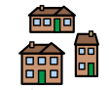  - Do you know anything about your house’s past? Who lived there before, or anything that has happened in your house before you lived there?  - Do you have any information about historic Willoughby?
French  Make a model of your favourite seasion inside a shoebox. Label it with a descriptive sentence you have learned. Example: Ma saison préférée, c'est l'été.    En été, le soleil brille et il fait chaud.    En hiver, il fait froid et il neige.    Au printemps les fleurs poussent et les oiseaux chantent.    En automne les arbres perdent leurs feuilles. | Science  - Sit somewhere quietly for 10 minutes and make a list of the sounds you can hear.    - Can you identify what is making each sound? What direction is it coming from? Is it nearby or further away? What is the pitch of the sound?  - Can you work scientifically and record your observations in a table?
PSHE  How can you make someone else feel good every day?  - Write a list with your family and give it a go. Can you fill a basket with lovely acts of kindness?    - Bake a cake or make food of your choice to share to help everyone in the class feel good! | 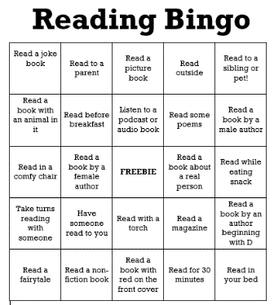  Can you complete one line on Reading Bingo? How about two lines? Who can complete the whole bingo sheet? Ms Smith determined to join in too so make sure you keep her updated with how you’re getting on! Mrs Basigara will be interested too!

