Year 1/2 Creative Homework
Summer 2 2025
This half term we will be learning about, food and nutrition and making couscous. Australia is the Geography topic. We are looking at the use of food in Art and the artist Paul Cezanne and finally, in RE we are focusing on the question ‘Who is Muslim and how do they live?’ So, to immerse yourself further within these topics we are setting optional homework tasks. Select an activity or activities from the choosing grid – you can complete as many as you like and be creative!
During the week beginning 22nd July we will be having a homework showcase where you will get the chance to share your amazing work so please bring everything in that week. Alternatively, you can email pictures or documents to office@willoughby.notts.sch.uk and we can share them with the class. We look forward to seeing all your efforts!
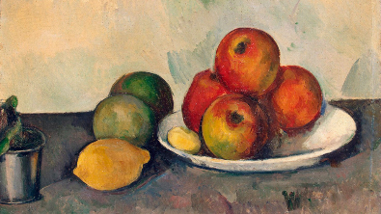  Paul Cezanne was famous for his still life painting that emphasized color, shape, and space.  Draw a still life picture, that involves food, in the style of Cezanne. Then carefully colour it using pencil crayons or paint it. | 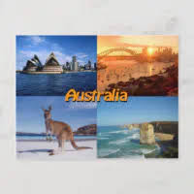  Imagine you are visiting Australia…  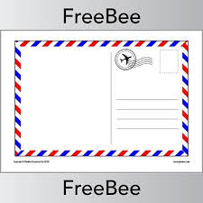  What have you seen or done there? Have you gone to the beach, seen a kangaroo, visited the city, or explored nature?  Write a postcard home about your Australian adventure. Don’t forget to draw a picture of your Australia adventure on the front of your postcard.
Make Your Own Fact Page!    Choose 3 interesting facts about Australia. You can look in a book, ask an adult, or use the internet (with help to stay safe online).  Write them in your own words or draw pictures to show them. | 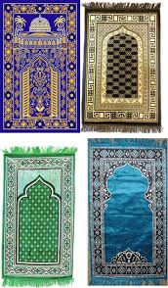  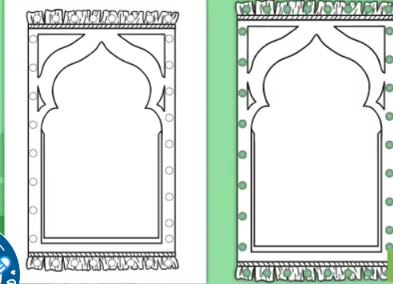  Many Muslims use prayer mats when performing their daily prayers.  Design a prayer mat you can use the example to base your design on.
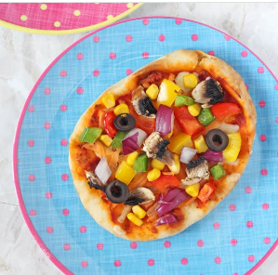  Family activity - Make a pizza.  Practice your cutting and slicing skills and make a pizza. For the base you could use pitta bread, a tortilla, premade pizza dough or even make your own dough. The choice is yours.  You can add any toppings you and your family like. Recipe idea - https://www.myfussyeater.com/diy-pitta-naan-bread-pizza-kids-recipe/  Remember to ask an adult to help you, knives are sharp and ovens are hot!  Take a photo of your finished pizza. Maybe eat it outside in the garden or go for a picnic. | 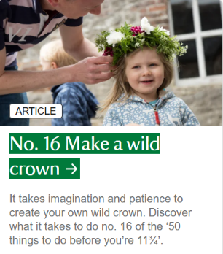  Make flower crown it can be a simple daisy chain crown. Maybe you could add a feather or different type of flower or leaves.  Remember to check that any flower or leaves are safe to pick and use.  Take a photo of your crown. Who will you make your for?

