Year 1/2 Creative Homework
Autumn 1 2025
Next half term we will be learning about Animals including humans in Science, how Weather is depicted with a focus on J.M.W. Turner in Art, DT focuses on greetings card with a slider mechanism.
To immerse yourself further within these topics we are setting optional homework tasks. Select an activity or activities from the choosing grid – you can complete as many as you like!
During the week beginning 13th October we will be having a homework showcase where your child will get the chance to share any of their marvellous creations so please bring everything in that week. Alternatively, you can email pictures or documents to office@willoughby.notts.sch.uk and we can share them with the class. We look forward to seeing all your amazing work!
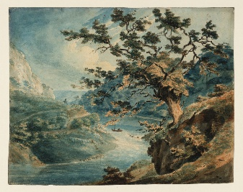  On a walk or visit to a park sketch a picture of the landscape including the type of weather – clouds, sun, colour of the sky you colour using crayons. | 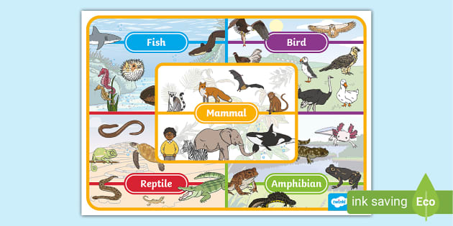  Create a poster showing an animal from the different animal groups – eg a bat for mamals, a clown fish for fish, a frog for amphibians etc  You can use any media you like.
Have a go at making your own picture using a simple sliding mechanism picture.  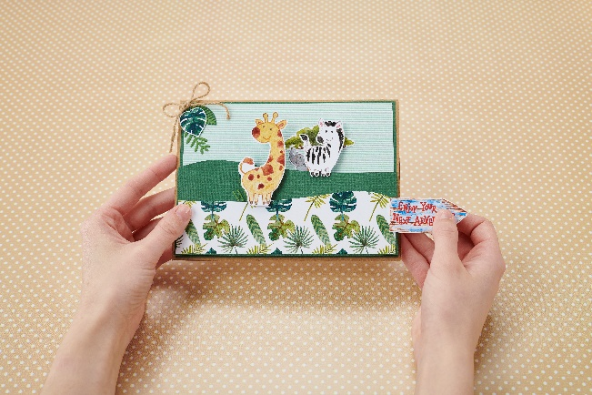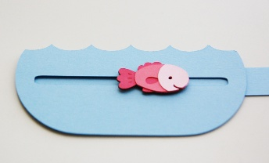 | Using non-fiction books and or the internet (remember get a grown up to help keep you safe on line), research a chosen ocean finding out some interesting facts eg which is the largest ocean?  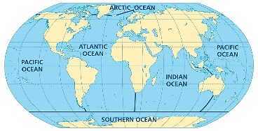
Investigate Carry out a saltwater vs. freshwater test. Comparing how objects, such as an egg, sink or float differently in freshwater and saltwater due to saltwater's higher density.  See the attached instructions and recording sheet. Remember you can also take photos.  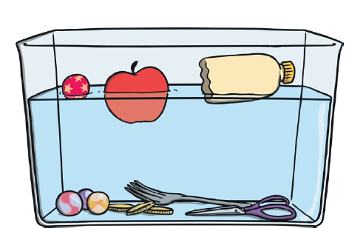 | 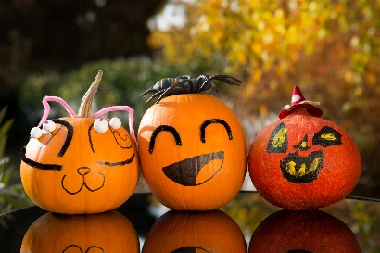  Perfect pumpkins. Can you go pumpkin picking or buy one from a shop? Make a pumpkin face then use the inside flesh to make a pumpkin food item eg muffins or hot pumpkin wedges. You can find ideas here https://www.bbcgoodfood.com/howto/guide/pumpkin-recipes-kids  Don’t forget to take photos or short video.

