Year 5/6 Creative Homework
Summer 1 2026
This half term we will be learning about evolution and inheritance in science, changing landscapes in geography, cultural traditions in art, vector drawing in computing and ‘being my best’ in PSHE. To immerse yourself further with our school topics we are setting these exciting homework tasks. Select an activity or activities from the choosing grid – we would like you to complete at least one please!
We will be having a homework showcase during the week beginning Monday 18th May where we can celebrate your amazing work so please bring everything in that week. Alternatively, you can email pictures or documents to office@willoughby.notts.sch.uk and we can share them with the class. We look forward to seeing all your efforts!
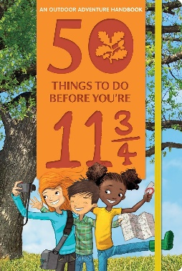  Eat a picnic outdoors: Number 9 on the list of ‘50 things to do before you’re 11¾’.  Now that the weather is getting warmer, make a picnic and eat it outside. Enjoy with family, friends, some teddies or a pet. Remember to take a photo. | We will be learning about Batik techniques in Art.  We will also be learning about an artist from Kenya who uses this technique.  Can you research Kenyan traditional culture or create a Kenyan-inspired design- maybe even on fabric?
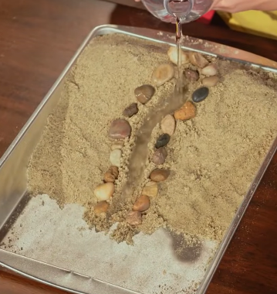  We are learning about weathering in Geography. Create an erosion model (search Erosion Model DIY with Zoe). Make a video or write a description about what’s happening. Use the terminology: weathering, erosion and deposition.  Explain what happens when the water is poured slower or faster. | In PSHE we are learning aboout Being My Best!  When and how are you ‘at your best@  Is it when you have: Eaten well? Exercised? Done a good deed? With friemds and family?  Make a collage of you when you are AT YOUR BEST!
For scientists, inheritance refers to the physical features that are passed from parents to children. Get a photo of both parents and one of you (or choose 2 celebrities and their child). Write down which characteristics you have inherited from which parent (e.g. eye colour, hair texture, nose shape). Have you acquired any behaviours too?  .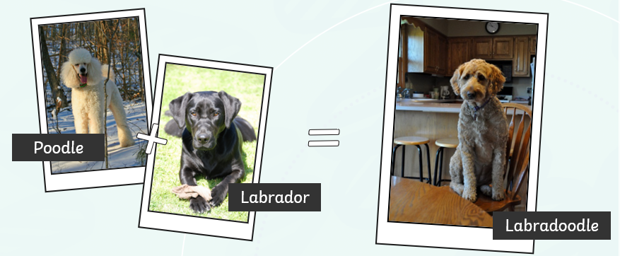 | Broken Calculator Challenge  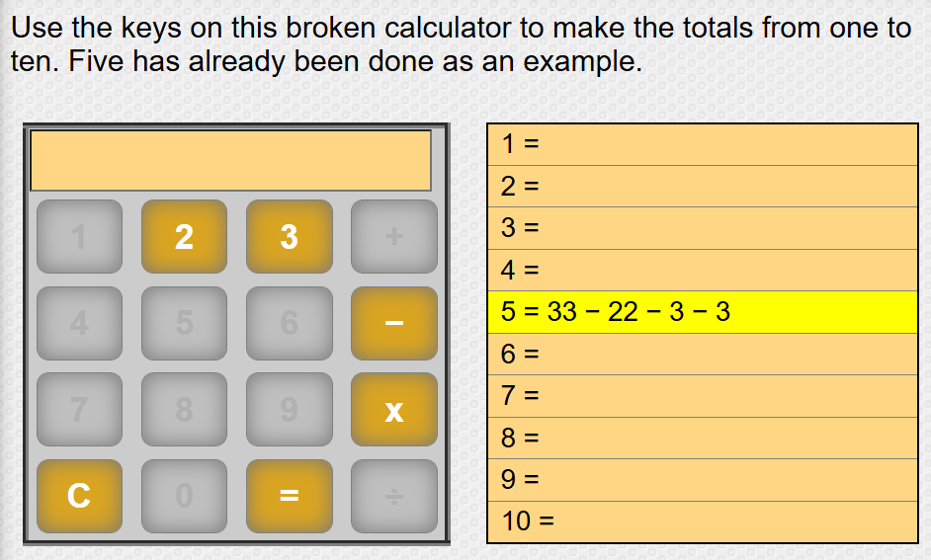  Record your sequences on a piece of paper

