Year 5/6 Creative Homework
Spring 2 2026
This half term we will be learning about classifying organisms in science, the UK civil war in history, frame structures in DT lessons, the meaning of being a Muslim in RE and rights and responsibilities in PSHE. To immerse yourself further within these topics we are setting these exciting homework tasks. Select an activity or activities from the choosing grid – we would like you to complete at least one please!
We will be having a homework showcase during the week beginning Monday 23rd March where we can celebrate your amazing work so please bring everything in that week. Alternatively, you can email pictures or documents to office@willoughby.notts.sch.uk and we can share them with the class. We look forward to seeing all your efforts!
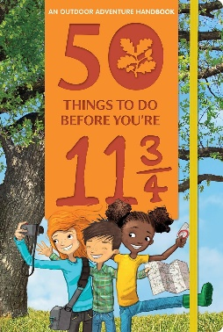  Fly a Kite: Number 7 on the list of ‘50 things to do before you’re 11¾’.  When there's a bit of wind in the air it's the perfect time to enjoy flying a kite. We will also be looking at kite structures in DT. Take a photo and email to us! | Ramadan is a special month in the Islamic calendar, when Muslims fast, pray, and do charitable activities. This year Ramadan falls between 17th February and 18th March. Can you fill a "good deed jar" with daily challenges like “help set the table,” “recite a short prayer,” “tidy my room”, “read to my sibling”, or “compliment a family member.”  Pick a task each day and show kindness and consideration for friends and family. You will learn skills of empathy, generosity, and responsibility.
In history, we are learning about the UK Civil War. Take a journey through one of the weirdest, wildest periods in English history, featuring the only time that a king has been tried and executed for treason!  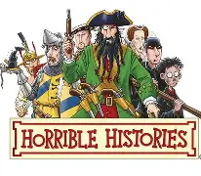  Watch Horrible Histories series 10, episode 9 – the Chaotic Civil War (can be found on BBC iPlayer) | Talk about what you have learned about rights and responsibilities. Use the website to remind you (search ‘rules, rights and responsibilities bbc’).  https://www.bbc.co.uk/bitesize/articles/zqgm7yc#zx7jjsg  Imagine a new play park has opened in Willoughby. Design a poster with the rules, rights and responsibilities for everyone who wants to play there.
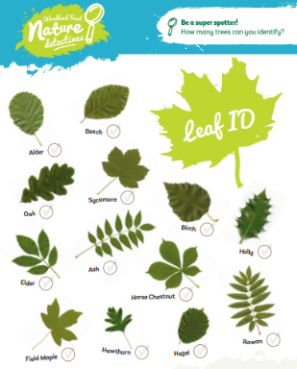  In science we are classifying organisms. Go on a leaf hunt and collect as many different leaves as you can. Can you arrange and group the leaves based on shared characteristics (colour, shape, veins, size)? Use what we have learnt in class to help you. | It’s World Book Day in March and to celebrate reading and our love of books at Willoughby Primary School, can you write your own book?  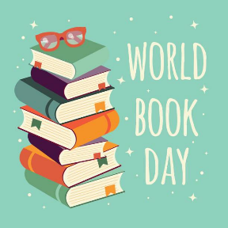  It could be a short story, an information booklet, a fun zine, a graphic novel, a cartoon written on iMovie with voice overs or a poem displayed on a PowerPoint slideshow. Be creative! And have fun!

