Year 5/6 Creative Homework
Spring 1 2026
This half term we will be learning about animals (including humans) in science, international trade in geography, the work of Kandinsky in art lessons, keeping ourselves safe in PSHE and visiting a tea room in French. To immerse yourself further within these topics we are setting these exciting homework tasks. Select an activity or activities from the choosing grid – we would like you to complete at least one please!
We will be having a homework showcase during the week beginning Monday 9th February where we can celebrate your amazing work so please bring everything in that week. Alternatively, you can email pictures or documents to office@willoughby.notts.sch.uk and we can share them with the class. We look forward to seeing all your efforts!
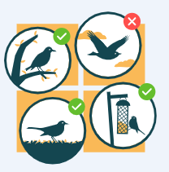  Take part in the RSPB Big Garden Bird watch on the weekend of 23rd - 25th January.  Sit quietly, count and record any birds you see. All information and record sheets can be found on the RSPB website -  https://www.rspb.org.uk/whats-happening/big-garden-birdwatch .  Bring your recording sheet in to school. | 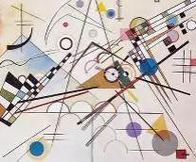  Kandinsky’s art was often inspired by music. Turn on your favourite piece of music and whilst you listen create a piece of abstract art that includes:  - different shapes  - different types of lines  - A mix of warm and cool colours  - A feeling or mood you want to express (e.g., calm, excitement, mystery).  Write notes to explain how the music inspired you.
Can you design a tea room menu in French?  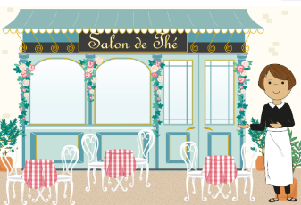  Remember to add food and drink. You will also need to think about whether to use ‘un’ or ‘une’ for each item. | 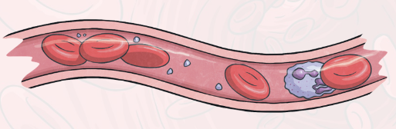  Make a blood collage! You will need to include: plasma, red blood cells, white blood cells and platelets. Label the parts and explain their function.
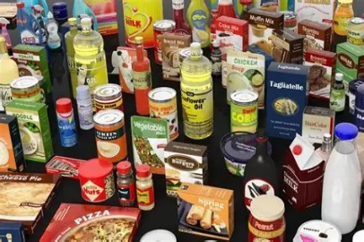  Look at the food packaging on 10 items and find out the ‘food miles’ for each item – you could draw or label this on a world map.  How many items can you find that are produced in England? | 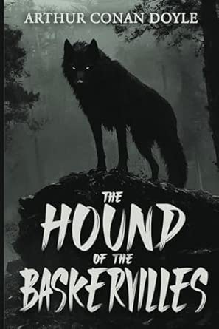  We are reading the Hounds of the Baskervilles in English and using the story to write our own cliff hanger narratives. Can you write your own mystery novel? Make it into a book with pictures, type it on the computer or create a graphic novel. Can you make your story full of suspense which puts me on the edge of my seat?

