Year 3/4 Creative Homework
Summer 1 2026
This half term we will be learning about plants in science, changing landscapes in geography, cultural traditions in art, the story of Jemmy Button in English and ‘being my best’ in PSHE. To immerse yourself further with our school topics we are setting these exciting homework tasks. Select an activity or activities from the choosing grid – we would like you to complete at least one please!
We will be having a homework showcase during the week beginning Monday 18th May where we can celebrate your amazing work so please bring everything in that week. Alternatively, you can email pictures or documents to office@willoughby.notts.sch.uk and we can share them with the class. We look forward to seeing all your efforts!
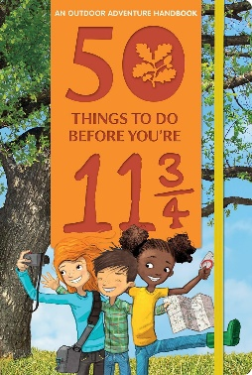  Eat a picnic outdoors: Number 9 on the list of ‘50 things to do before you’re 11¾’.  Now that the weather is getting warmer, make a picnic and eat it outside. Enjoy with family, friends, some teddies or a pet. Remember to take a photo. | We will be learning about Batik techniques in Art.  We will also be learning about an artist from Kenya who uses this technique.  Can you research Kenyan traditional culture or create a Kenyan-inspired design- maybe even on fabric?
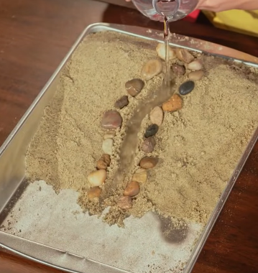  We are learning about weathering in geography. Create an erosion model (search Erosion Model DIY with Zoe). Make a video or write a description about what’s happening. Use the terminology: weathering, erosion and deposition.  Explain what happens when the water is poured slower or faster. | English This term we are reading the book Jemmy Button. But who was this person? What was his real name, where did he come from, where did he travel. Use this website to find out about the real Jemmy Button. Jemmy Button Facts for Kids  Can you draw a map to show where Jemmy travelled. Label it to show things that were the same and things that were different in the places he travelled to.
Fraction Hunt at Home! Look around your home and find unit fractions in real life. Remember a unit fraction has a numerator of one, and the denominator tells us how many parts are in the whole. Examples might be:  Half an orange 🍊  One quarter of a chocolate bar 🍫  One slice from a loaf of bread 🍞  One roll from a pack of toilet rolls.  Take photographs and of the different examples you find, and write the unit fraction next to each photo. | In PSHE we are learning aboout Being My Best!  When and how are you ‘at your best@  Is it when you have: Eaten well? Exercised? Done a good deed? With friemds and family?  Make a collage of you when you are AT YOUR BEST!

