Year 1/2 Creative Homework
Summer 2026
Next half term we will be learning about Polar regions, Identifying and growing plants and in Art we are looking at seascapes and Monet in our foundation subjects. To immerse yourself further within these topics we are setting optional homework tasks. Select an activity or activities from the choosing grid – you can complete as many as you like!
During the week beginning 18th May we will be having a homework showcase where your child will get the chance to share any of their marvellous creations so please bring everything in that week. Alternatively, you can email pictures or documents to office@willoughby.notts.sch.uk and we can share them with the class. We look forward to seeing all your amazing work!
Scenes of the sea – Paint or draw a picture of the sea. Is your sea calm or rough? Is there anything on the sea? If you were on the sea what could you see?  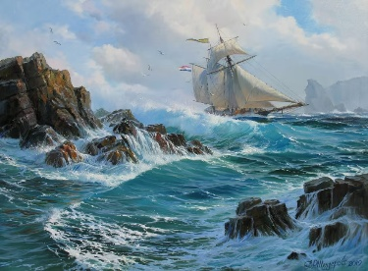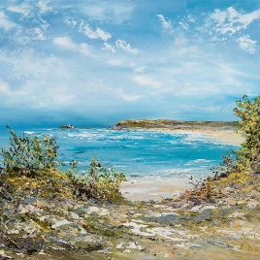 | 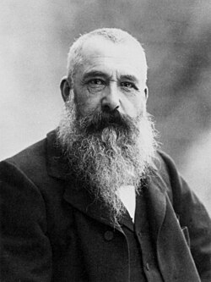  In Art we are looking at the artist Claude Monet. Research – find out about some of his famous paintings, when and where he painted them. Which is your favourite?
Create a fact file on your favourite polar animal. Don’t forget to include a picture of your animal.  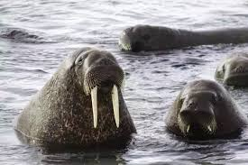 | 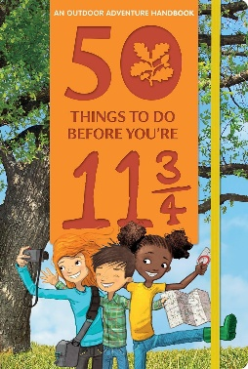  Eat a picnic outdoors: Number 9 on the list of ‘50 things to do before you’re 11¾’.  Now that the weather is getting warmer, make a picnic and eat it outside. Enjoy with family, friends, some teddies or a pet. Remember to take a photo!
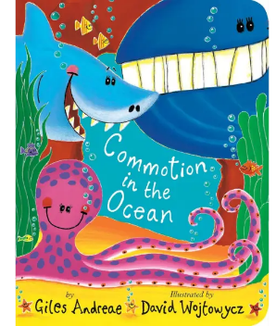  In English we are reading the last Wolf. Find an animal story book and write a book review. Take a photo of you with your book. You could make a recording of you reading some of your book. | 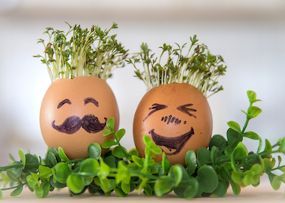  Grow cress in the most unusual container you can find. Remember to water it and put it sunlight. Take a photo of your grown cress.

