Year 1/2 Creative Homework
Spring 1 2026
Next half term we will be learning about the uses of everyday materials, The United Kingdom and Pointillism focusing on the artist George Seurat in our foundation subjects. To immerse yourself further within these topics we are setting optional homework tasks. Select an activity or activities from the choosing grid – you can complete as many as you like!
During the week beginning 9th February we will be having a homework showcase where your child will get the chance to share any of their marvellous creations so please bring everything in that week. Alternatively, you can email pictures or documents to office@willoughby.notts.sch.uk and we can share them with the class. We look forward to seeing all your amazing work!
Take part in the Big Garden Bird watch.  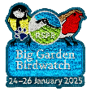  Weekend of the 23rd - 25th January.  Sit quietly, count and record any birds you see. All information and record sheets can be found on the RSPB website -  https://www.rspb.org.uk/whats-happening/big-garden-birdwatch .  Then if you would like register and upload your results on the RSPB website.  Bring in your recording sheet in to school. | Feed the birds.  To help our feathered friends make a bird feeder.  https://www.rspb.org.uk/helping-nature/what-you-can-do/activities/feed-the-birds for ideas  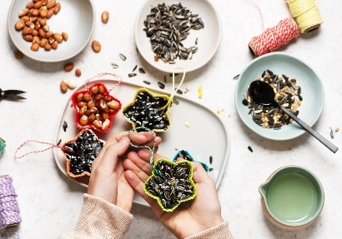
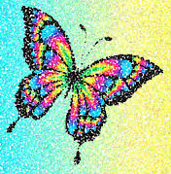    Like the artist George Seurat create a picture using the style of Pointillism. .  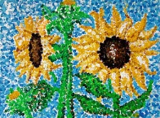 Remember to dot carefully! | Make an information poster advertising your favourite place to visit in the United Kingdom. It maybe a town by the sea like Skegness or Blackpool or the place relatives live. Do have a photo of you there? What it there to do? Is it famous for something?
Design a prayer mat. You can use any media you like (felt pens, paint, crayons etc)  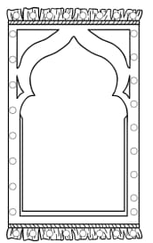  Think carefully about the patterns and the outline shapes you use. | Take a photograph of the first spring flower that you see.    What is the name of the flower?

