Year 1/2 Creative Homework
Autumn 1 2026
This half term we are learning about Seasonal Changes in Science, and how artists such as Georgia O’Keeffe took inspiration from nature. In Geography we have been learning about the United Kingdom, and its four countries: England, Scotland, Northern Ireland and Wales.
To immerse us further within these topics we are setting optional homework tasks. Select an activity or activities from the choosing grid – you can complete as many as you like!
During the week beginning 12th October we will be having a homework showcase where your child will get the chance to share any of their marvellous creations, so please bring everything in that week. Alternatively, you can email pictures or documents to office@willoughby.notts.sch.uk and we can share them with the class. We look forward to seeing all of your amazing work!
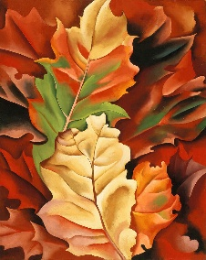  On a walk or visit to a park, sketch a picture of something that inspires you in nature – trees, leaves, flowers… | Create a poster all about one, or all, of the four seasons. Think about the weather, and the changes you may spot in that season.  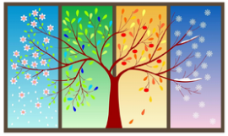  You can use any media you like.
Can you spot early signs of Autumn? Take a photograph of something Autumnal you see when you are outside.  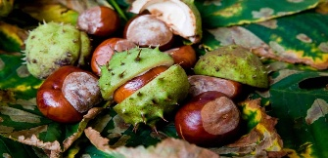 | In PE we have been developing agility, balance and coordination. You could try one of these!  - Balance: Have a go at walking along a straight line without stepping off. You could lay a skipping rope down to walk along. What is the furthest you can go?  - Agility: Wacky Weave! Place 5 or 6 soft items in a straight line on the floor (teddies or cushions) and weave in and out of them. Challenge yourself to get quicker at the weave!  - Coordination: Play balloon ’Keepy-Uppy’, how long can you keep a balloon in the air?
Choose a human or physical landmark (river, building, mountain…) in one of the four countries we have been learning about. Have a go at building it in Lego, blocks, recycled boxes or anything you have to hand. Don’t forget to label it with its name and country. Use the internet with a trusted adult to find out some facts about your chosen landmark.
